PROJECT REPORT

ON

**“ Kerala:- God’s Own Country ”**

***for the partial submission of O Level Software (Certificate in Business Professional Programmer) to the National Institute of Electronics and Information Technology under Ministry of Information and Communication Technology, Govt. of India, New Delhi.***

**SUBMITTED BY**

**Miss.** **Pranali .B. Maraskolhe**

**(Reg. No. 1502135)**

**Director Project Guide**

**Mr. Jagdeepsingh Thakur Mrs. Sarala Kumbalpuri**



**SUBMITTED TO**

# SIGMA COMPUTERS

Plot No.1, Medical College Rd, Medical College Chowk, Hanuman Nagar, Nagpur, Maharashtra 440009.

[www.sigmacomputer.org](http://www.sigmacomputer.org/)

**SESSION 2022-2023**

**STUDENT DECLARATION**

I, **Miss Pranali .B. Maraskolhe** students of **“SIGMA COMPUTERS, NAGPUR”** here by declare that the Project report entitled **“Kerala- God’s Own Country”** is complete and submitted under guidance of Mr. SEKHAR RAO SIR is my original work. The imperial finding in this report is based on the data collected by me. I have submitted this project report to SIGMA OCMPUTERS, NAGPUR for the Educational Purpose.

DATE: 20/12/2021

**Miss.** **Pranali .B. Maraskolhe**

**(Reg. No. 1502135)**

# SIGMA COMPUTERS

Plot No.1, Medical College Rd, Medical College Chowk, Hanuman Nagar, Nagpur, Maharashtra 440009.

[www.sigmacomputer.org](http://www.sigmacomputer.org/)

**ACKNOWLEDGEMENT**

I acknowledge the sincere assistance provided to me from several rather unexpected quarters during the course of execution of this study. It would be a mammoth task to place on record my gratitude to each and every one of them but a whole hearted attempt would be made nevertheless, least I be branded ungrateful.

I am extremely thankful to MR. THAKUR SIR & Mrs. Sarala Kumbalpuri guidance and constant supervision as well as for providing necessary information regarding the project & also for their support in completing the project.

Where we would like to express my gratitude toward my friends and member of sigma computer Nagpur for their kind co-operation and encouragement which help me in completion on this project.

We also extend our heart fell thanks to our family and well-wishers….

**INTRODUCTION**

Hyper Text Markup Language (HTML) is the main markup language for creating web pages and other information that can be displayed in a web browser.

HTML is written in the form of HTML elements consisting of tags enclosed in angle brackets (like <html>), within the web page content HTML tags most commonly come in pairs like <h1> and

<4111>,although some tags represent empty elements and so are unpaired, for example <img>. The first tag in pair is the start tag, and the second tag is end tag (they are also called opening tags and closing tags) in between these tags web designers can add text, further tags, comments and other types of text-based content.

The purpose of a web browser is to read HTML documents and compose them into visible or audible web pages. The browser does not display the HTML tags, but uses the tags to interpret the content of the page.

HTML element form the building blocks of all websites. HTML allows images and objects to be embedded and can be used to create interactive forms. It provides a means to create structured documents by denoting structural semantics for text such as headings, paragraphs, lists, links, quotes and other items. It can embed scripts written in languages such as JavaScript which affect the behavior of HTML web pages.

Web browsers can also refer to cascading style sheets (CSS) to define the appearance and lay out of text and other material. The W3C, maintainer of both the HTML and the CSS standards, encourages the use of CSS over explicit presentational HTML.

**INDEX**

|  |  |  |
| --- | --- | --- |
| **Sr. No.** | **Contents** | **Page No** |
| 1 | Student Declaration | 2 |
| 2 | Acknowledgement | 3 |
| 3 | Introduction | 4 |
| 4 | Home Page | 6 |
| 5 | History | 22 |
| 6 | Climate & People | 24 |
| 7 | Goverment | 28 |
| 8 | Food | 32 |

**Home Page**

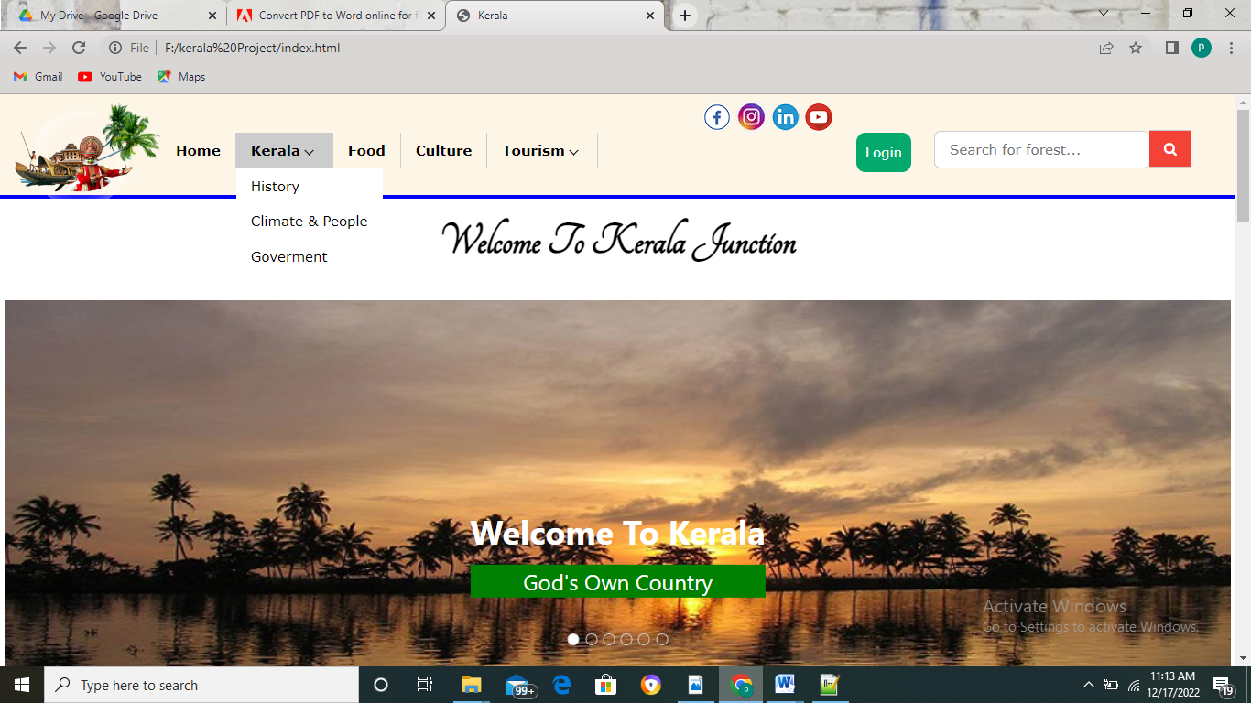

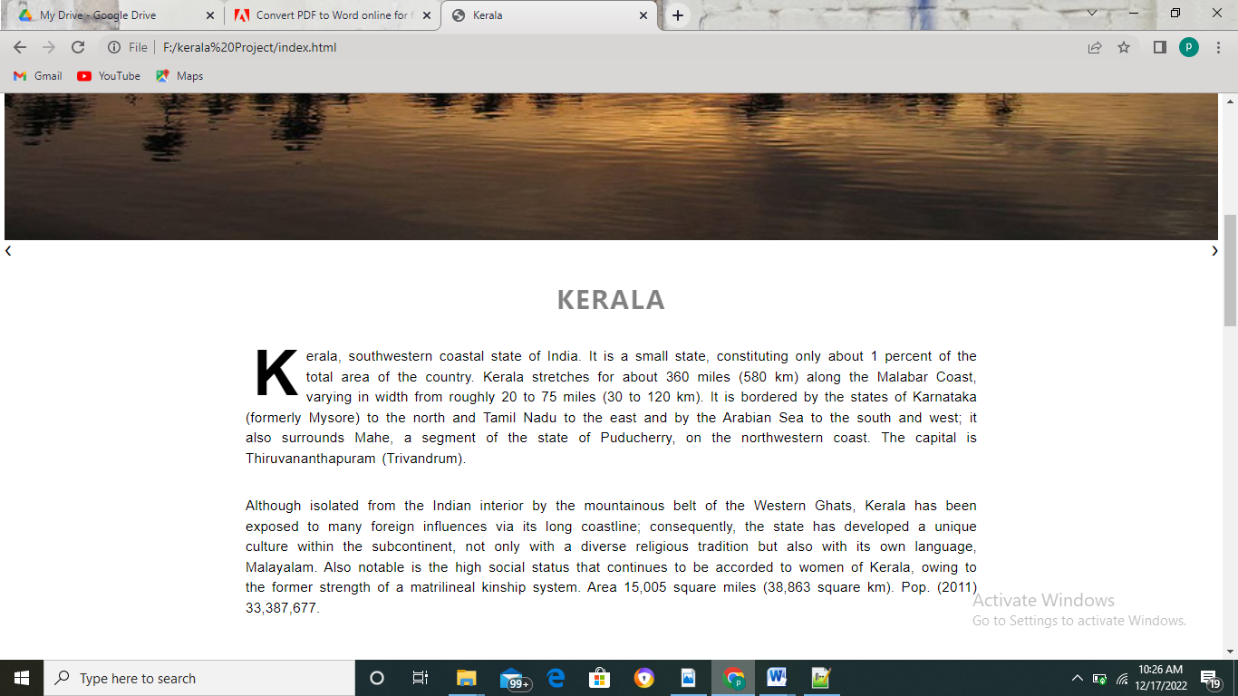

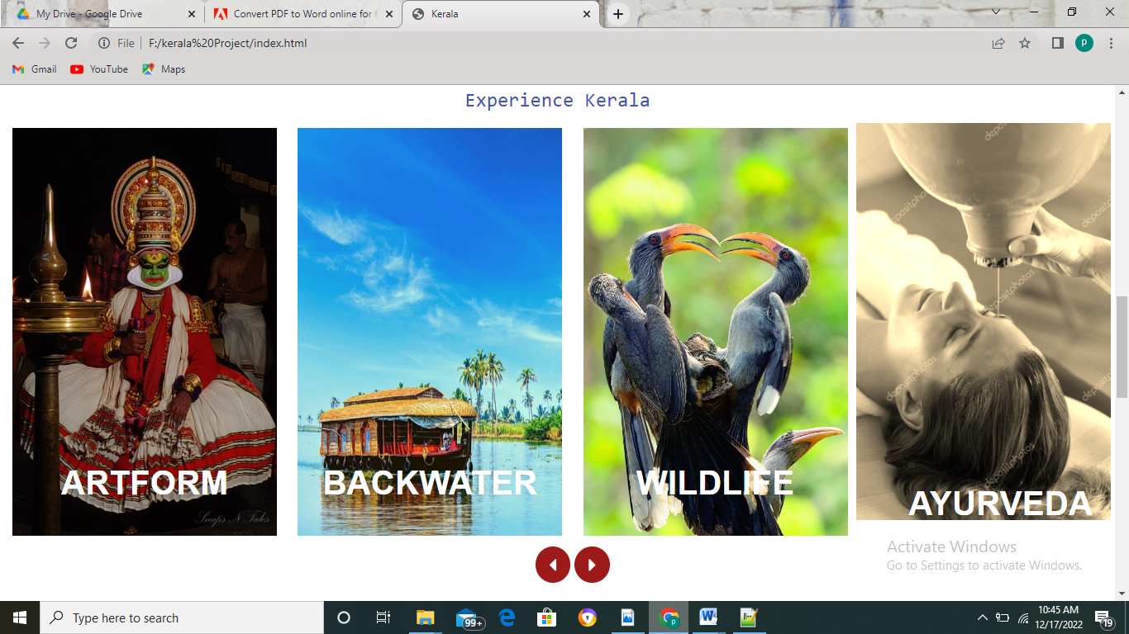

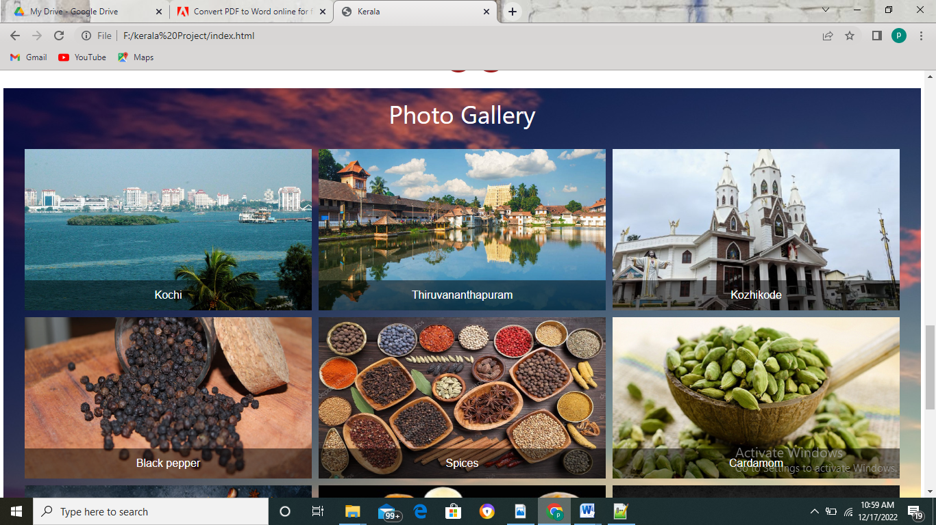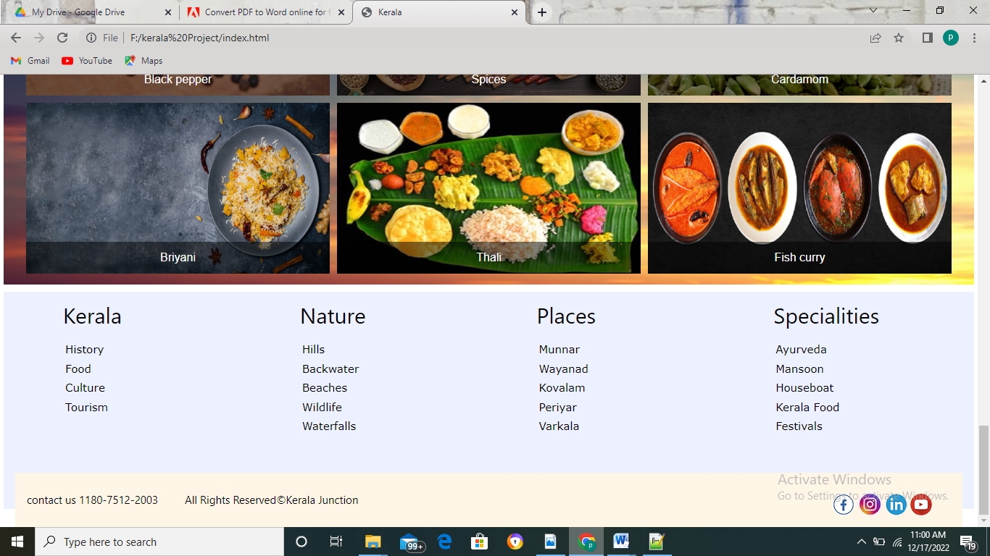

**Code of Home Page (index.html)**

<!doctype html>

<html>

<head>

<title>Kerala</title>

<meta name="viewport" content="width=device-width, initial-scale=1">

<link rel="stylesheet" type="text/css" href="\kerala Project\css\w3.css">

<link rel="stylesheet" type="text/css" href="\kerala Project\css\kerala-index.css">

<link rel="stylesheet" type="text/css" href="\kerala Project\css\photo_slide.css">

<link rel="stylesheet" href="https://fonts.googleapis.com/css?family=Sofia">

<link rel="stylesheet" href="https://www.w3schools.com/lib/w3-colors-win8.css">

<link rel="stylesheet" href="https://cdnjs.cloudflare.com/ajax/libs/font-awesome/4.7.0/css/font-awesome.min.css">

<link rel="stylesheet" href="https://www.w3schools.com/lib/w3-colors-highway.css">

<link rel="stylesheet" href="https://fonts.googleapis.com/css?family=Tangerine">

<link rel="stylesheet" href="https://www.w3schools.com/lib/w3-colors-2020.css">

</head>

<body>

<div class="w3-container header w3-sand">

<div class="w3-bar nav">

<img src="/kerala Project/img/kerala-logo.png" style="float: left;width: 160px;">

<a href="/kerala Project/index.html" class="w3-bar-item w3-button w3-border-right" style="margin-top: 35px;font-weight: bold;">Home<a>

<div class="w3-dropdown-hover">

<button class="w3-button w3-border-right" style="margin-top: 35px;font-weight: bold;">Kerala<i class="arrow down"></i></button>

<div class="w3-dropdown-content w3-bar-block w3-card4">

<a href="/kerala Project/history-kerala.html" class="w3-bar-item w3-button w3-hover-black">History</a>

<a href="/kerala Project/kerala-climate.html" class="w3-bar-item w3-button w3-hover-black">Climate & People</a>

<a href="/kerala Project/goverment.html" class="w3-bar-item w3-button w3-hover-black">Goverment</a>

</div>

</div>

<div class="w3-dropdown-hover">

<a href="./food.html" class="w3-button w3-border-right" style="margin-top: 35px; font-weight: bold;">Food</a>

</div>

<div class="w3-dropdown-hover">

<a href="./food.html" class="w3-button w3-border-right" style="margin-top: 35px; font-weight: bold;">Culture</a>

</div>

<div class="w3-dropdown-hover">

<button class="w3-button w3-border-right" style="margin-top: 35px; font-weight: bold;">Tourism<i class="arrow down"></i></button>

<div class="w3-dropdown-content w3-bar-block w3-card4">

<a href="#" class="w3-bar-item w3-button w3-hover-black">Beach</a>

<a href="#" class="w3-bar-item w3-button w3-hover-black">Hostel</a>

<a href="#" class="w3-bar-item w3-button w3-hover-black">Safari</a>

</div>

</div>

<div class="search" style="margin: 25px;float: right;">

<input type="text" class="w3-bar-item w3-input w3-border-top w3-border-bottom w3-border-left" style="border-radius: 7px;" placeholder="Search for forest...">

<a href="#" class="w3-bar-item w3-button w3-red w3-border-top w3-border-bottom" style="margin-top: 7px;margin-right: 7px;"><i class="fa fa-search"></i></a>

</div>

<button class="but" onclick="document.getElementById('id01').style.display='block'" style="width: auto;margin: 35px 0 0 0;padding: 10px;float: right;border-radius: 10px;">Login</button>

<div id="id01" class="modal">

<form class="modal-content animate" action="/action_page.php" method="post">

<div class="container">

<span onclick="document.getElementById('id01').style.display='none'" class="close" title="Close Modal">&times;</span>

<label for="uname"><b>Username</b></label>

<input type="text" placeholder="Enter Username" name="uname" required>

<label for="psw"><b>Password</b></label>

<input type="password" placeholder="Enter Password" name="psw" required>

<button class="but" type="submit" style="height: 30px;">Login</button>

<label>

<input type="checkbox" checked="checked" name="remember"> Remember me

</label>

</div>

<div class="container" style="background-color:#f1f1f1">

<button type="button" onclick="document.getElementById('id01').style.display='none'" class="cancelbtn but">Cancel</button>

<span class="psw">Forgot <a href="#">password?</a></span>

</div>

</form>

</div>

<div class="w3-container" style="float: right; margin-right: 10px;">

<a href="https://www.facebook.com/" target="_blank"><img src="/kerala Project/img/facebook.png" class="w3-circle"></a>

<a href="https://www.instagram.com/accounts/login/" target="_blank"><img src="/kerala Project/img/insta.jpg" class="w3-circle" ></a>

<a href="https://in.linkedin.com/" target="_blank"><img src="/kerala Project/img/link2.png" class="w3-circle"></a>

<a href="https://www.youtube.com/" target="_blank"><img src="/kerala Project/img/yt2.png" class="w3-circle"></a>

</div>

</div></div><hr>

<div class="w3-container ">

<h2 class="w3-center w3-tangerine">Welcome To Kerala Junction</h2>

</div>

<div class="w3-content w3-section" style="max-width:100%; margin: 5px 5px 5px 5px;">

<div class="slide">

<img class="mySlides" src="/kerala Project/img/munnar1.jpg" style="width:100%;">

<div class="w3-display-middle w3-large w3-container" style="top: 80%;">

<h1 class="text" style="color: white;font-weight: bold;">Welcome To Kerala</h1>

<div style="background: green;">

<h3 style="color: white;text-align: center;">God's Own Country</h3>

</div>

</div>

<img class="mySlides" src="/kerala Project/img/slide1.jpg" style="width:100%;">

<img class="mySlides" src="/kerala Project/img/slide2.jpg" style="width:100%;">

<img class="mySlides" src="/kerala Project/img/slide3.jpg" style="width:100%;">

<img class="mySlides" src="/kerala Project/img/elephant.jpg" style="width:100%;">

<img class="mySlides" src="/kerala Project/img/jatau.jpg" style="width:100%;">

<div class="w3-left w3-hover-text-khaki" onclick="plusDivs(-1)">&#10094;</div>

<div class="w3-right w3-hover-text-khaki" onclick="plusDivs(1)">&#10095;</div>

<div class="w3-center w3-container w3-section w3-large w3-text-white w3-display-bottommiddle" style="width:100%">

<span class="w3-badge demo w3-border w3-transparent w3-hover-white" onclick="currentDiv(1)"></span>

<span class="w3-badge demo w3-border w3-transparent w3-hover-white" onclick="currentDiv(2)"></span>

<span class="w3-badge demo w3-border w3-transparent w3-hover-white" onclick="currentDiv(3)"></span>

<span class="w3-badge demo w3-border w3-transparent w3-hover-white" onclick="currentDiv(4)"></span>

<span class="w3-badge demo w3-border w3-transparent w3-hover-white" onclick="currentDiv(5)"></span>

<span class="w3-badge demo w3-border w3-transparent w3-hover-white" onclick="currentDiv(6)"></span>

</div>

</div>

<div class="w3-container">

<h5 class="w3-center" style="word-spacing:3px;letter-spacing:1.3px;font-weight: bold;margin-top:20px;font-size: 30px;opacity: 0.5;">KERALA</h5>

<p class="tree para">Kerala, southwestern coastal state of India. It is a small state, constituting only about 1 percent of the total area of the country. Kerala stretches for about 360 miles (580 km) along the Malabar Coast, varying in width from roughly 20 to 75 miles (30 to 120 km).

It is bordered by the states of Karnataka (formerly Mysore) to the north and Tamil Nadu to the east and by the Arabian Sea to the south and west; it also surrounds Mahe, a segment of the state of Puducherry, on the northwestern coast.

The capital is Thiruvananthapuram (Trivandrum).

<p class="para">Although isolated from the Indian interior by the mountainous belt of the Western Ghats, Kerala has been exposed to many foreign influences via its long coastline; consequently,

the state has developed a unique culture within the subcontinent, not only with a diverse religious tradition but also with its own language, Malayalam. Also notable is the high social status that continues to be accorded to women of Kerala,

owing to the former strength of a matrilineal kinship system. Area 15,005 square miles (38,863 square km). Pop. (2011) 33,387,677.</p>

</p>

</div>

<div class="w3-container">

<h3 class="w3-center w3-monospace w3-text-indigo">Experience Kerala</h3>

</div>

<div class="photo">

<div class="container-fluid">

<div class="slider-wrap">

<div class="slider-main" id="slider-main">

<div class="item">

<div class="image"><img src="/kerala Project/img/art.jpg" style="width:320px;height: 500px;" class="w3-hover-sepia">

<div class="w3-container w3-display-bottommiddle">

<p style="font-size: 40px;">ARTFORM</p>

</div>

</div>

</div>

<div class="item">

<div class="image"><img src="/kerala Project/img/backwater1.jpg" style="width:320px;height: 500px;" class="w3-hover-sepia">

<div class="w3-container w3-display-bottommiddle">

<p style="font-size: 40px;">BACKWATER</p>

</div>

</div>

</div>

<div class="item">

<div class="image"><img src="/kerala Project/img/bird.jpg" style="width:320px;height: 500px;" class="w3-hover-sepia">

<div class="w3-container w3-display-bottommiddle">

<p style="font-size: 40px;">WILDLIFE</p>

</div>

</div>

</div>

<div class="item">

<div class="image"><img src="/kerala Project/img/aur-oil.jpg" style="width:320px;height: 500px;" class="w3-hover-sepia">

<div class="w3-container w3-display-bottommiddle">

<p style="font-size: 40px;">AYURVEDA</p>

</div>

</div>

</div>

<div class="item">

<div class="image"><img src="/kerala Project/img/ele.jpg" style="width:320px;height: 500px;" class="w3-hover-sepia">

<div class="w3-container w3-display-bottommiddle">

<p style="font-size: 40px;">FESTIVALS</p>

</div>

</div>

</div>

<div class="item">

<div class="image"><img src="/kerala Project/img/beach.jpg" style="width:320px;height: 500px;" class="w3-hover-sepia">

<div class="w3-container w3-display-bottommiddle">

<p style="font-size: 40px;">Beaches</p>

</div>

</div>

</div>

</div>

</div>

<div class="button_area">

<button type="button" class="slider-btn" onclick="prev()"><i class="fa fa-caret-left" aria-hidden="true"></i></button>

<button type="button" class="slider-btn" onclick="next()"><i class="fa fa-caret-right" aria-hidden="true"></i></button>

</div>

</div>

</div>

<div class="w3-container picture" style="margin-top: 80px;">

<h1 class="w3-center" style="color: white;">Photo Gallery</h1>

<div class="grid-container">

<div class="grid-item"><img src="/kerala Project/img/kochi.jpg" style="width: 100%;">

<div class="title">

<span class="caption">Kochi</span>

</div>

</div>

<div class="grid-item"><img src="/Kerala Project/img/Thiruvananthapuram.jpg" style="width: 100%;">

<div class="title">

<span class="caption" >Thiruvananthapuram</span>

</div>

</div>

<div class="grid-item"><img src="/kerala Project/img/Kozhikode.jpg" style="width: 100%;">

<div class="title">

<span class="caption" >Kozhikode</span>

</div>

</div>

<div class="grid-item"><img src="/kerala Project/img/spice1.jpg" style="width: 100%;">

<div class="title">

<span class="caption cap1" >Black pepper</span>

</div>

</div>

<div class="grid-item"><img src="/kerala Project/img/spice2.jpg" style="width: 100%;">

<div class="title">

<span class="caption cap1">Spices</span>

</div>

</div>

<div class="grid-item"><img src="/kerala Project/img/spice3.jpg" style="width: 100%;">

<div class="title">

<span class="caption cap1">Cardamom</span>

</div>

</div>

<div class="grid-item"><img src="/kerala Project/img/briyani.jpg" style="width: 100%;">

<div class="title">

<span class="caption cap2">Briyani</span>

</div>

</div>

<div class="grid-item"><img src="/kerala Project/img/thali.jpg" style="width: 100%;">

<div class="title">

<span class="caption cap2">Thali</span>

</div>

</div>

<div class="grid-item"><img src="/kerala Project/img/fish.jpg" style="width: 100%;">

<div class="title">

<span class="caption cap2">Fish curry</span>

</div>

</div>

</div>

</div>

<footer class="w3-container w3-2020-brilliant-white" style="height: 300px;margin-top: 10px;">

<div class="w3-row">

<div class="w3-quarter w3-container w3-bar w3-content">

<h2 style="margin-left:50px;">Kerala</h2>

<table>

<tr>

<td><a href="#" class="w3-hover-text-red">History</a></td>

</tr>

<tr>

<td><a href="#" class="w3-hover-text-red">Food</a></td>

</tr>

<tr>

<td><a href="#" class="w3-hover-text-red">Culture</a></td>

</tr>

<tr>

<td><a href="#" class="w3-hover-text-red">Tourism</a></td>

</tr>

</table>

</div>

<div class="w3-quarter w3-container w3-bar w3-content">

<h2 style="margin-left:50px;">Nature</h2>

<table>

<tr>

<td><a href="#" class="w3-hover-text-red">Hills</a></td>

</tr>

<tr>

<td><a href="#" class="w3-hover-text-red">Backwater</a></td>

</tr>

<tr>

<td><a href="#" class="w3-hover-text-red">Beaches</a></td>

</tr>

<tr>

<td><a href="#" class="w3-hover-text-red">Wildlife</a></td>

</tr>

<tr>

<td><a href="#" class="w3-hover-text-red">Waterfalls</a></td>

</tr>

</table>

</div>

<div class="w3-quarter w3-container w3-bar w3-content">

<h2 style="margin-left:50px;">Places</h2>

<table>

<tr>

<td><a href="#" class="w3-hover-text-red">Munnar</a></td>

</tr>

<tr>

<td><a href="#" class="w3-hover-text-red">Wayanad</a></td>

</tr>

<tr>

<td><a href="#" class="w3-hover-text-red">Kovalam</a></td>

</tr>

<tr>

<td><a href="#" class="w3-hover-text-red">Periyar</a></td>

</tr>

<tr>

<td><a href="#" class="w3-hover-text-red">Varkala</a></td>

</tr>

</table>

</div>

<div class="w3-quarter w3-container w3-bar w3-content">

<h2 style="margin-left:50px;">Specialities</h2>

<table>

<tr>

<td><a href="#" class="w3-hover-text-red">Ayurveda</a></td>

</tr>

<tr>

<td><a href="#" class="w3-hover-text-red">Mansoon</a></td>

</tr>

<tr>

<td><a href="#" class="w3-hover-text-red">Houseboat</a></td>

</tr>

<tr>

<td><a href="#" class="w3-hover-text-red">Kerala Food</a></td>

</tr>

<tr>

<td><a href="#" class="w3-hover-text-red">Festivals</a></td>

</tr>

</table>

</div>

</div>

<div class="container w3-sand" style="margin-top: 50px;">

<h4 style="font-size: 15px;">contact us 1180-7512-2003 &nbsp;&nbsp;&nbsp;&nbsp;&nbsp;&nbsp;&nbsp; All Rights Reserved&copy;Kerala Junction

&nbsp;&nbsp;&nbsp;&nbsp;

<div class="w3-container" style="float: right; margin-right: 10px;">

<a href="https://www.facebook.com/" target="_blank"><img src="/kerala Project/img/facebook.png" class="w3-circle"></a>

<a href="https://www.instagram.com/accounts/login/"><img src="/kerala Project/img/insta.jpg" class="w3-circle" ></a>

<a href="https://in.linkedin.com/"><img src="/kerala Project/img/link2.png" class="w3-circle"></a>

<a href="https://www.youtube.com/"><img src="/kerala Project/img/yt2.png" class="w3-circle"></a>

</div>

</h4>

</div>

</footer>

<script>

var i;

var sliderMain = document.getElementById("slider-main");

var item = sliderMain.getElementsByClassName("item");

function next(){

sliderMain.append(item[0]);

}

function prev(){

sliderMain.prepend(item[item.length-1]);

}

</script>

<script src="/kerala Project/javascript/kerala-js.js"></script>

</body>

</html>

**Css Code Of Home Page(Kerala-index.css)**

ul a{

text-decoration: none;

float: right;

padding-top: 10px 20px;

}

.w3-tangerine{

font-family: "Tangerine", serif;

}

hr{

border: solid 2px blue;

margin: 0px;

width: auto;

}

.arrow{

border: solid 1px black;

border-width: 0 1px 1px 0;

display: inline-block;

padding: 3px;

margin: 2px 6px;

}

.down{

transform: rotate(45deg);

}

.arrow-pop{

border: solid 2px white;

border-width: 0 2px 2px 0;

display: inline-block;

padding: 3px;

margin-right: 10px;

margin-bottom: 5px;

}

.down-pop{

transform: rotate(45deg);

}

div.nav{

margin-top: 7px;

}

.header{

height: 110px;

}

.slide-container{

position: relative;

width: 90%;

margin: 0 200px 0 60px;

}

.slide img{

width: 90%;

margin: 10px 200px 0 60px;

height: 600px;

}

.arrow-1{

cursor: pointer;

position: absolute;

top: 75%;

color: black;

padding: 8px 18px;

border: 3px;

opacity: 0.5;

font-size: 25px;

font-weight: bold;

background-color: ;

}

.next{

right: 90px;

}

.prev{

left: 70px;

}

.slide{

display: none;

}

.w3-tangerine {

font-family: "Tangerine", serif;

font-size: 50px;

font-weight: bold;

color:

}

.tree::first-letter{

font-weight: bold;

font-size: 70px;

float: left;

line-height: 50px;

padding: 8px;

margin-top: -3px;

}

.para{

text-align: justify;

margin: 30px 250px;

line-height: 1.5;

letter-spacing: 0.3px;

word-spacing: 2px;

font-family: sans-serif;

}

.w3-container p{

line-height: 1.5;

letter-spacing: 0.3px;

word-spacing: 2px;

font-family: sans-serif;

}

table tr td a{

text-decoration: none;

margin-left: 50px;

}

aside{

float: left;

padding: 0 15px 5px 0;

}

input[type=text], input[type=password] {

width: 100%;

padding: 12px 20px;

margin: 8px 0;

display: inline-block;

border: 1px solid #ccc;

box-sizing: border-box;

}

button {

background-color: #04AA6D;

color: white;

border: none;

cursor: pointer;

width: 100%;

}

button:hover {

opacity: 0.8;

}

.cancelbtn {

width: auto;

padding: 10px 18px;

background-color: #f44336;

}

.container {

padding: 16px;

}

span.psw {

float: right;

padding-top: 16px;

}

.modal {

display: none; /* Hidden by default */

position: fixed; /* Stay in place */

z-index: 1; /* Sit on top */

left: 0px;

top: 0px;

width: 100%; /* Full width */

height: 100%; /* Full height */

overflow: auto; /* Enable scroll if needed */

background-color: rgb(0,0,0); /* Fallback color */

background-color: rgba(0,0,0,0.4); /* Black w/ opacity */

padding-top: 60px;

}

.modal-content {

background-color: #fefefe;

margin: 5% auto 15% auto; /* 5% from the top, 15% from the bottom and centered */

border: 1px solid #888;

width: 400px; /* Could be more or less, depending on screen size */

}

.close {

position: absolute;

right: 25px;

top: 100px;

right: 400px;

color: #000;

font-size: 35px;

font-weight: bold;

}

.close:hover,.close:focus {

color: red;

cursor: pointer;

}

.animate {

animation: animatezoom 0.6s

}

@keyframes animatezoom {

from {transform: scale(0)}

to {transform: scale(1)}

}

@media screen and (max-width: 300px) {

span.psw {

display: block;

float: none;

}

.cancelbtn {

width: 100%;

}

}

.pop:hover{

text-decoration: underline white 1px;

}

**Javascript Code Of Home Page(Kerala-js.js)**

var myIndex = 0;

carousel();

function currentDiv(n) {

showDivs(slideIndex = n);

}

function carousel() {

var i;

var x = document.getElementsByClassName("mySlides");

var dots = document.getElementsByClassName("demo");

for (i = 0; i < x.length; i++) {

x[i].style.display = "none";

}

for (i = 0; i < dots.length; i++) {

dots[i].className = dots[i].className.replace(" w3-white", "");

}

myIndex++;

if (myIndex > x.length) {myIndex = 1}

x[myIndex-1].style.display = "block";

dots[myIndex-1].className += " w3-white";

setTimeout(carousel, 2000); // Change image every 2 second

**Histroy Of Kerala**

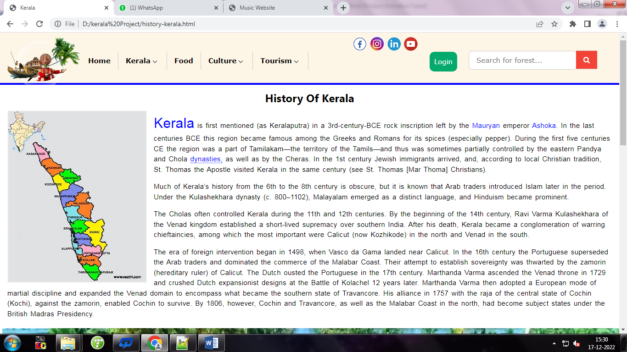

**Histroy Of Kerala (history-kerala.html)**

<div class="w3-container">

<h3 style="font-weight: bold;" class="w3-center">History Of Kerala</h3>

<aside><img src="/kerala Project/img/kerala-map1.jpg" alt="kerala-map" style="border: 2px solid #f2f2f2;"></aside>

<p class="kerala"><span style="color: blue;font-size:30px;">Kerala</span> is first mentioned (as Keralaputra) in a 3rd-century-BCE rock inscription left by the <span style="color: blue;">Mauryan</span> emperor <span style="color: blue;">Ashoka</span>.

In the last centuries BCE this region became famous among the Greeks and Romans for its spices (especially pepper).

During the first five centuries CE the region was a part of Tamilakam—the territory of the Tamils—and thus was sometimes partially controlled by the eastern Pandya and Chola <span style="border-bottom: dotted 1px; color: blue;">dynasties,</span>

as well as by the Cheras. In the 1st century Jewish immigrants arrived, and, according to local Christian tradition,

St. Thomas the Apostle visited Kerala in the same century (see St. Thomas [Mar Thoma] Christians).

</p>

<p>Much of Kerala’s history from the 6th to the 8th century is obscure, but it is known that Arab traders introduced Islam later in the period.

Under the Kulashekhara dynasty (c. 800–1102), Malayalam emerged as a distinct language, and Hinduism became prominent.

</p>

<p>The Cholas often controlled Kerala during the 11th and 12th centuries. By the beginning of the 14th century, Ravi Varma Kulashekhara of the Venad kingdom established a short-lived supremacy over southern India.

After his death, Kerala became a conglomeration of warring chieftaincies, among which the most important were Calicut (now Kozhikode) in the north and Venad in the south.

</p>

<p>The era of foreign intervention began in 1498, when Vasco da Gama landed near Calicut. In the 16th century the Portuguese superseded the Arab traders and dominated the commerce of the Malabar Coast.

Their attempt to establish sovereignty was thwarted by the zamorin (hereditary ruler) of Calicut. The Dutch ousted the Portuguese in the 17th century. Marthanda Varma ascended the Venad throne in 1729

and crushed Dutch expansionist designs at the Battle of Kolachel 12 years later. Marthanda Varma then adopted a European mode of martial discipline and expanded the Venad domain to encompass what became the southern state of Travancore.

His alliance in 1757 with the raja of the central state of Cochin (Kochi), against the zamorin, enabled Cochin to survive. By 1806, however, Cochin and Travancore, as well as the Malabar Coast in the north, had become subject states under the British Madras Presidency.

</p>

</div>

<video width="100%" height="20%" controls style="margin: 5px;">

<source src="kerala-vedio1.mp4">

</video>

**Climate and People**

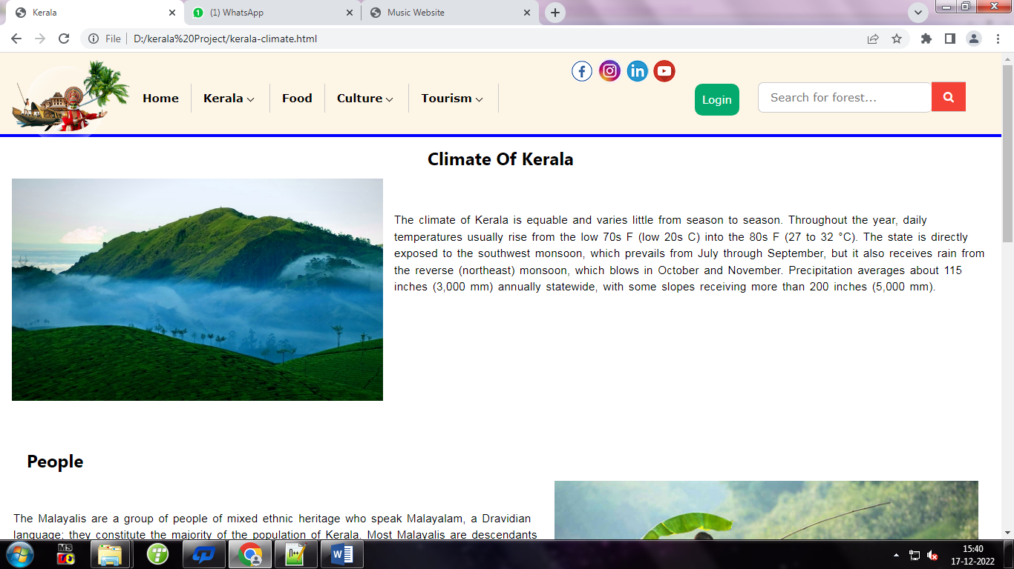 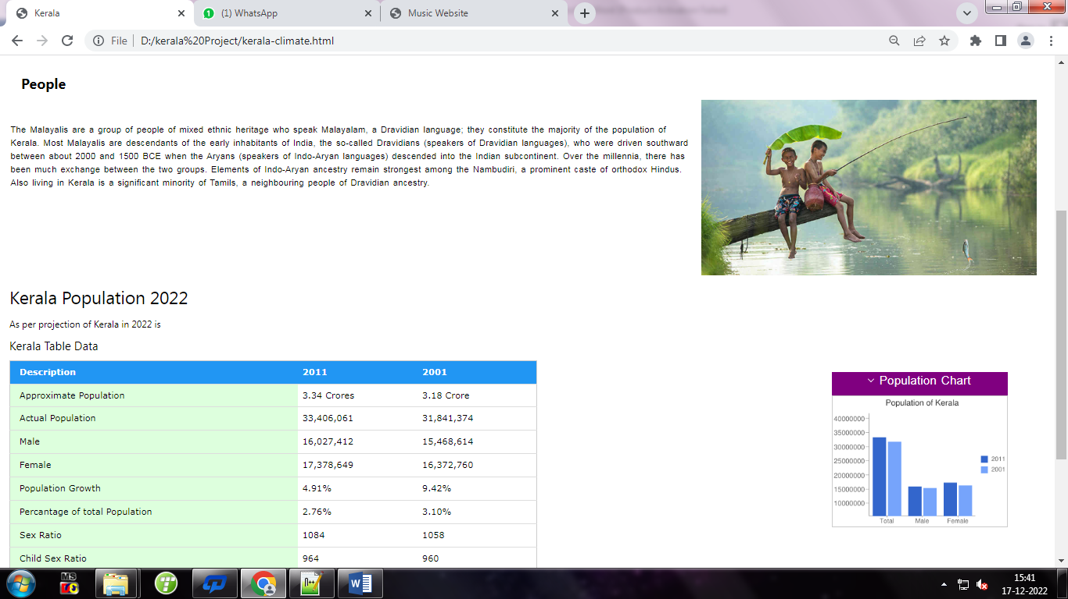

**Climate and People (kerala-climate.html)**

<div class="w3-container">

<h3 class="w3-center" style="font-weight: bold;">Climate Of Kerala</h3>

<aside><img src="/kerala Project/img/Kerala Climate (3).jpg" alt="climate-map" style="height: 300px;width: 500px"></aside>

<p style="margin-top: 55px;">The climate of Kerala is equable and varies little from season to season. Throughout the year, daily temperatures usually rise from the low 70s F (low 20s C) into the 80s F (27 to 32 °C).

The state is directly exposed to the southwest monsoon, which prevails from July through September, but it also receives rain from the reverse (northeast) monsoon, which blows in October and November.

Precipitation averages about 115 inches (3,000 mm) annually statewide, with some slopes receiving more than 200 inches (5,000 mm).</p>

</div><br>

<div class="w3-container" style="margin-top: 9px;">

<h3 style="font-weight: bold;margin-top: 25px;margin-bottom: 10px;">&nbsp;&nbsp;&nbsp;People</h3>

<aside style="float: right;"><img src="/kerala Project/img/rain1.jpg" alt="climate-map" style="height: 300px ;float: right;margin-left: 15px;"></aside>

<p style="margin: 0 2px 0 2px;margin-top: 50px;">The Malayalis are a group of people of mixed ethnic heritage who speak Malayalam, a Dravidian language; they constitute the majority of the population of Kerala. Most Malayalis are descendants of the early inhabitants of India,

the so-called Dravidians (speakers of Dravidian languages), who were driven southward between about 2000 and 1500 BCE when the Aryans (speakers of Indo-Aryan languages) descended into the Indian subcontinent.

Over the millennia, there has been much exchange between the two groups. Elements of Indo-Aryan ancestry remain strongest among the Nambudiri, a prominent caste of orthodox Hindus. Also living in Kerala is a significant minority of Tamils,

a neighbouring people of Dravidian ancestry.</p>

</div>

<div class="w3-container">

<h3 style="font-size: 30px;">Kerala Population 2022</h3>

<h6>As per projection of Kerala in 2022 is</h6>

<h4>Kerala Table Data</h4>

<table class="w3-table w3-border w3-bordered" style="float: left;width: 900px;">

<thead>

<tr class="w3-blue">

<th>Description</th>

<th>2011</th>

<th>2001</th>

</tr>

<tr>

<td class="w3-pale-green">Approximate Population</td>

<td>3.34 Crores</td>

<td>3.18 Crore</td>

</tr>

<tr>

<td class="w3-pale-green">Actual Population</td>

<td>33,406,061</td>

<td>31,841,374</td>

</tr>

<tr>

<td class="w3-pale-green">Male</td>

<td>16,027,412</td>

<td>15,468,614</td>

</tr>

<tr>

<td class="w3-pale-green">Female</td>

<td>17,378,649</td>

<td>16,372,760</td>

</tr>

<tr>

<td class="w3-pale-green">Population Growth</td>

<td>4.91%</td>

<td>9.42%</td>

</tr>

<tr>

<td class="w3-pale-green">Percantage of total Population</td>

<td>2.76%</td>

<td>3.10%</td>

</tr>

<tr>

<td class="w3-pale-green">Sex Ratio</td>

<td>1084</td>

<td>1058</td>

</tr>

<tr>

<td class="w3-pale-green">Child Sex Ratio</td>

<td>964</td>

<td>960</td>

</tr>

</thead>

</table>

<div class="w3-container" style="height: 320px; width:320px;float: right;margin-right: 60px;">

<div>

<p style="background-color: purple;font-size: 20px;text-align: center;color: white;height: 40px;width:300px;" class="pop"><i class="arrow-pop down-pop w3-border-round"></i>Population Chart</p>

<img src="/kerala Project/img/population-chart.png" style="margin-top: -20px;width:300px" class="w3-border">

</div>

</div>

</div>

**Government**

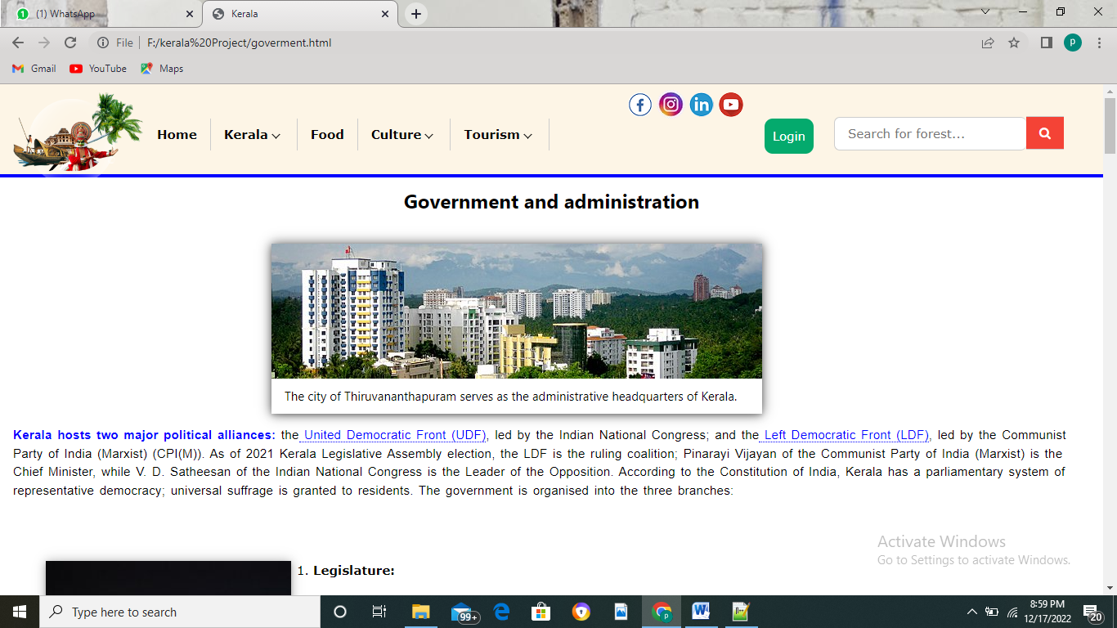

**Government (government.html)**

<div class="w3-container">

<h3 style="font-weight: bold;" class="w3-center">Government and administration</h3>

<div class="w3-container">

<div class="w3-third" style="margin-top: 25px;margin-left: 300px;width: 600px;box-shadow: 0px 0px 15px rgba(0,0,0,0.22);box-shadow: 0px 0px 15px rgba(0,0,0,0.60);">

<div class="w3-card">

<img src="/kerala Project/img/admin.jpg" style="width: 600px;height: 165px;">

<div class="w3-container">

<h5 style="font-size: 15px;width: 600px;">The city of Thiruvananthapuram serves as the administrative headquarters of Kerala.</h5>

</div>

</div>

</div>

</div>

<p><span style="color: blue;font-weight: bold;">Kerala hosts two major political alliances:</span> the<span style="border-bottom: dotted 1px; color: blue;"> United Democratic Front (UDF)</span>, led by the Indian National Congress; and the<span style="border-bottom: dotted 1px; color: blue;"> Left Democratic Front

(LDF)</span>, led by the Communist Party of India (Marxist) (CPI(M)). As of 2021 Kerala Legislative Assembly election, the LDF is the ruling coalition; Pinarayi Vijayan of the Communist Party of India (Marxist) is the Chief Minister,

while V. D. Satheesan of the Indian National Congress is the Leader of the Opposition. According to the Constitution of India, Kerala has a parliamentary system of representative democracy; universal suffrage is granted to residents.

The government is organised into the three branches:</p><br><br>

<ol type="1">

<div class="w3-third" style="float: left;width: 300px;margin-right: 27px;box-shadow: 0px 0px 15px rgba(0,0,0,0.22);">

<div class="w3-card">

<img s src="/kerala Project/img/legis.jpg" style="width: 100%" class="w3-hover-sepia">

<div class="w3-container">

<h5>Legislative Assembly</h5>

</div>

</div>

</div>

<li><p>

<dt><b>Legislature:</b></dt> <dd class="para">The unicameral legislature, the Kerala Legislative Assembly popularly known as Niyamasabha, comprises elected members and special office bearers; the Speaker and Deputy Speaker elected by the members from among themselves.

Assembly meetings are presided over by the Speaker and in the Speaker's absence, by the Deputy Speaker. The state has 140 assembly constituencies. The state elects 20 and 9 members for representation in the Lok Sabha and the Rajya Sabha, respectively.

</dd></p></li><br><br><br><br><br><br><br>

<div class="w3-third" style="float: left;width: 300px;margin-right: 27px;box-shadow: 0px 0px 15px rgba(0,0,0,0.22);margin-top: 15px;">

<div class="w3-card">

<img src="/kerala Project/img/execute.jpg" style="width: 100%" class="w3-hover-sepia">

<div class="w3-container">

<h5>Executive Assembly</h5>

</div>

</div>

</div>

<li>

<p style="margin-top: 5px;margin-left: 2px;"><dt><b>Executive:</b></dt> <dd class="para" style="margin-top: 10px;text-align: left;"> The Governor of Kerala is the constitutional head of state, and is appointed by the President of India. Arif Mohammad Khan is the Governor of Kerala.

The executive authority is headed by the Chief Minister of Kerala, who is the head of government and is vested with extensive executive powers; the head of the majority party in the Legislative Assembly

is appointed to the post by the Governor. The Council of Ministers has its members appointed by the Governor, taking the advice of the Chief Minister.[266] The executive administration is based in Thiruvananthapuram at State Secretariat complex.

Each district has a district administrator appointed by government called District collector for executive administration. Auxiliary authorities known as panchayats, for which local body elections are regularly held, govern local affairs.

</dd></p></li><br><br><br><br>

<div class="w3-third" style="float: left;width: 300px;margin-right: 27px;box-shadow: 0px 0px 15px rgba(0,0,0,0.22);">

<div class="w3-card">

<img src="/kerala Project/img/highcourt.jpg" style="width: 100%" class="w3-hover-sepia">

<div class="w3-container">

<h5>Judiciary</h5>

</div>

</div>

</div>

<li>

<p><dt><b>Judiciary:</b></dt> <dd class="para">The judiciary consists of the Kerala High Court and a system of lower courts. The High Court, located in Kochi, has a Chief Justice along with 35 permanent and twelve additional pro tempore justices as of 2021. The high court also hears cases from the Union Territory of Lakshadweep.</dd></p>

</li><br>

</ol><br>

<div class="w3-container">

<h3>List of chief minister of kerala</h3>

<table class="w3-table-all w3-border w3-card w3-responsive" border="1">

<tr>

<th style="text-align: center">Sr no.</th>

<th style="text-align: center">Portrait</th>

<th style="text-align: center">Name (Birth–Death)</th>

<th style="text-align: center">Constituency</th>

<th style="text-align: center" colspan ="3">Tenure</th>

<th style="text-align: center">Assembly(election)</th>

<th style="text-align: center">Alliance</th>

<th style="text-align: center">Party</th>

</tr>

<tr>

<td>-</td>

<td><img src="/kerala Project/img/President Rule.png"></td>

<td style="text-align: center; padding-top: 40px;">Vacant(President Rule)</td>

<td style="text-align: center; padding-top: 40px;">N/A</td>

<td style="text-align: center;">1 November 1956</td>

<td style="text-align: center;">5 April 1957</td>

<td style="text-align: center;">155 days</td>

<td style="text-align: center; padding-top: 40px;">Dissolved</td>

<td style="text-align: center; padding-top: 40px;" colspan="2">N/A</td>

</tr>

**Food**

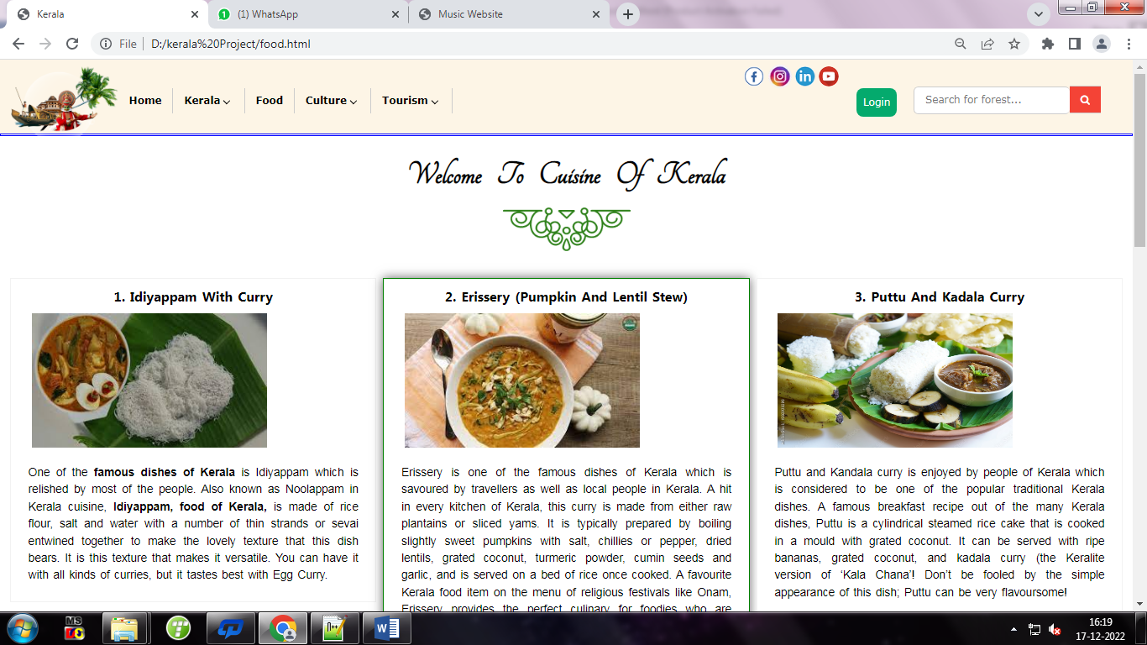 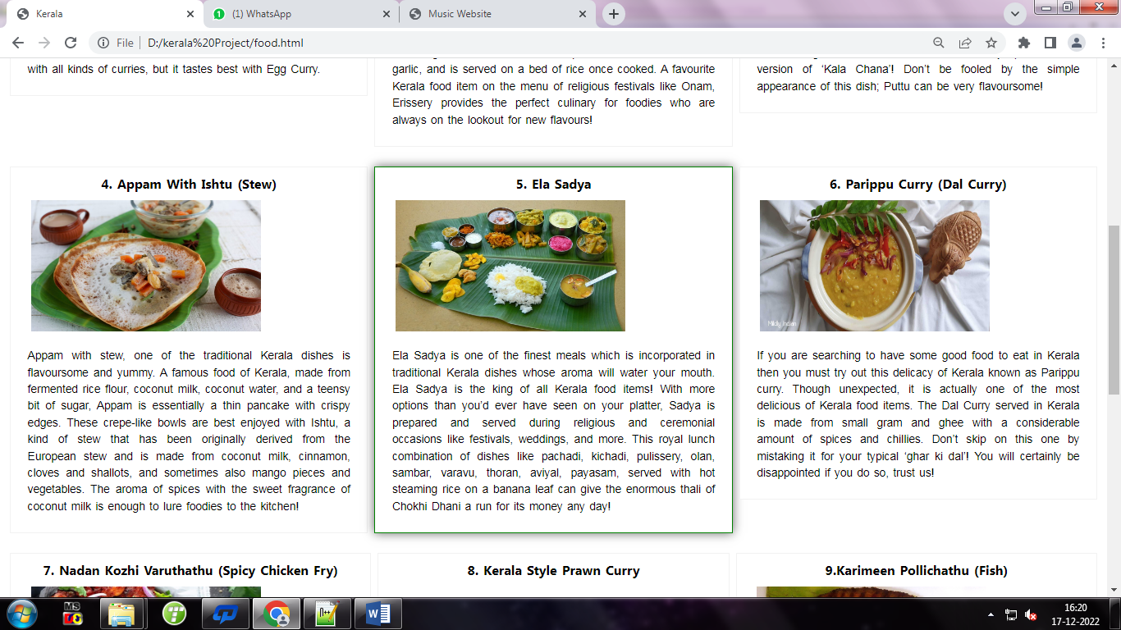

**Food(food.html)**

<div class="w-container">

<div class="head w3-tangerine">

<h1 class="w3-tangerine">Welcome &nbsp;&nbsp;To &nbsp;&nbsp;Cuisine&nbsp;&nbsp; Of&nbsp;&nbsp; Kerala<br>

<img src="./img/border.png" style="margin-top: 0;width: auto;">

</div>

<div class="grid-container">

<div class="grid-item">

<div class="food1">

<h3 style="font-weight: bold;font-size: 20px;text-align:center;">1. Idiyappam With Curry</h3>

<img src="./img/Idiyappam.jpg" style="width: 350px;margin-left: 30px;height: 200px;">

<p style="margin:25px;">

One of the <b>famous dishes of Kerala</b> is Idiyappam which is relished by most of the people.

Also known as Noolappam in Kerala cuisine,<b> Idiyappam, food of Kerala,</b> is made of rice flour, salt and water

with a number of thin strands or sevai entwined together to make the lovely texture that this dish bears. It is this texture that makes it versatile.

You can have it with all kinds of curries, but it tastes best with Egg Curry.

</p>

</div>

</div>

<div class="grid-item">

<div class="food1">

<h3 style="font-weight: bold;font-size: 20px;text-align:center;">2. Erissery (Pumpkin And Lentil Stew)</h3>

<img src="./img/Erissery.jpg" style="margin-left: 30px;width: 350px;height: 200px;">

<p style="margin:25px;">

Erissery is one of the famous dishes of Kerala which is savoured by travellers as well as local people in Kerala.

A hit in every kitchen of Kerala, this curry is made from either raw plantains or sliced yams.

It is typically prepared by boiling slightly sweet pumpkins with salt, chillies or pepper, dried lentils, grated coconut, turmeric powder, cumin seeds and garlic, and is served on a bed of rice once cooked.

A favourite Kerala food item on the menu of religious festivals like Onam, Erissery provides the perfect culinary for foodies who are always on the lookout for new flavours!

</p>

</div>

</div>

<div class="grid-item">

<div class="food1">

<h3 style="font-weight: bold;font-size: 20px;text-align:center;">3. Puttu And Kadala Curry</h3>

<img src="./img/Puttu.jpg" style="width: 350px;height: 200px;margin-left: 30px">

<p style="margin:25px;">

Puttu and Kandala curry is enjoyed by people of Kerala which is considered to be one of the popular traditional Kerala dishes. A famous breakfast recipe out of the many Kerala dishes,

Puttu is a cylindrical steamed rice cake that is cooked in a mould with grated coconut. It can be served with ripe bananas, grated coconut, and kadala curry (the Keralite version of

‘Kala Chana’! Don’t be fooled by the simple appearance of this dish; Puttu can be very flavoursome!

</p>

</div>

</div>

</div>

<div class="grid-container">

<div class="grid-item">

<div class="food1">

<h3 style="font-weight: bold;font-size: 20px;text-align:center;">4. Appam With Ishtu (Stew)</h3>

<img src="./img/Appam.jpg" style="width: 350px;height: 200px;margin-left: 30px">

<p style="margin:25px;">

Appam with stew, one of the traditional Kerala dishes is flavoursome and yummy. A famous food of Kerala, made from fermented rice flour, coconut milk, coconut water,

and a teensy bit of sugar, Appam is essentially a thin pancake with crispy edges. These crepe-like bowls are best enjoyed with Ishtu, a kind of stew that has been originally

derived from the European stew and is made from coconut milk, cinnamon, cloves and shallots, and sometimes also mango pieces and vegetables. The aroma of spices with the sweet

fragrance of coconut milk is enough to lure foodies to the kitchen!

</p>

</div>

</div>